Stage 2 Project Design

Work Log and Action List can be found in the zip folder along with this document titled “Stage2.zip”

Table of Contents
Feedback 3
Summary of feedback 3
Outline of feedback undertaken 3
Finalised proposed system (shaded are added and modified functionality) 4
Overall design 5
Structure diagram 5
Structure diagram explanation 5
Module 1: Login Error! Bookmark not defined.
Module 2: adding question and answer to database 10
Module 3: Linear Search 16

Feedback

Summary of feedback
(+) Good overall outline of functions
(+) Good screen design that can be used to get feedback
(+)Layout and screen designs are great and diagrams are labelled
(+)Good work log
(-) Change layout of document (portrait when needed, then landscape)
(-) Improve layout a some text in the boxes were cut out
(-) Actions to minimise risks
(-) Create a storyboard of the main functions
(-) Outline how people will be able to share to public
(-) For administrator, how will the manage users and approve public questions
(-) More detail is needed for functions and discussions (how they can work)
(-) Describe the sharing function into more detail

Outline of feedback undertaken
- Layout of document was changed
- Storyboard was created outlining the main functions
- Functionality was updated to show how people will be able to share, administrator would manage users and approve public questions
- From interview, client wanted to update screens for more clarity. This has been done on caccoo and also from twitter bootstraps mockup. The new screen designs are all in this document.

Finalised proposed system (shaded are added and modified functionality)
Note: Due to the limited time frame, test function will not be implemented in first version of StudyFlip.
- Administration (Can perform user functions and more)
  - Management can modify user accounts (ie. Change username, password, date of birth etc.)
  - Management can approve categories from students
- User management
  - Login Screen for individuals to access own account
  - Register for those who do not have an account (join via a form)
    - Verification via email
    - Verification by image recognition
    - Information stored in database
  - Forgot password for those who have forgotten their password details
    - Verification by email
    - Password sent to email from database
- Study
  - Student create subject and category (needs to be approved by administrator) for desired revision and organisation
  - Students create Q and ideal answer for revision, information stored in DB
  - Information can either be private or public for students disgression (for shared, author adds usernames to the “shared list”, once added it can be viewed by users on the list). Creation of study questions are set to private by default.
  - During study, answers are hidden until user presses ‘flip button’
  - Students can add, delete, modify study questions
  - Students write down answer (as the HSC is a written based examination, therefore after writing the answer on paper, students click the ‘flip button’ and compare their answer with the model answer
- Test
  - Students create subject and category (needs to be emailed and approved by administrator) for desired multiple choice test
  - Students create questions and answers, information stored in DB (pool of Q&A’s)
  - Prior to the test, students see the maximum number of questions that they can do, in a separate text box they specify how many questions they want to complete for that test.
  - Questions are randomised.
  - During the test, students read the question and click the best answer
  - As the student clicks next, the next question made comes straight up
  - Timer countdown for students to work with multiple choice questions under pressure
  - Students can add, delete, modify test questions and answers
  - Tests can be shared or private (for shared, author adds usernames to the “shared list”, once added it can be viewed by users on the list). Creation of tests are set to private by default.
- The system
  - Security: Passwords to database
  - Specified data type and character limit in forms (to prevent access and modification of database by use of code). This can be seen in the data dictionaries.

Overall design

Structure diagram
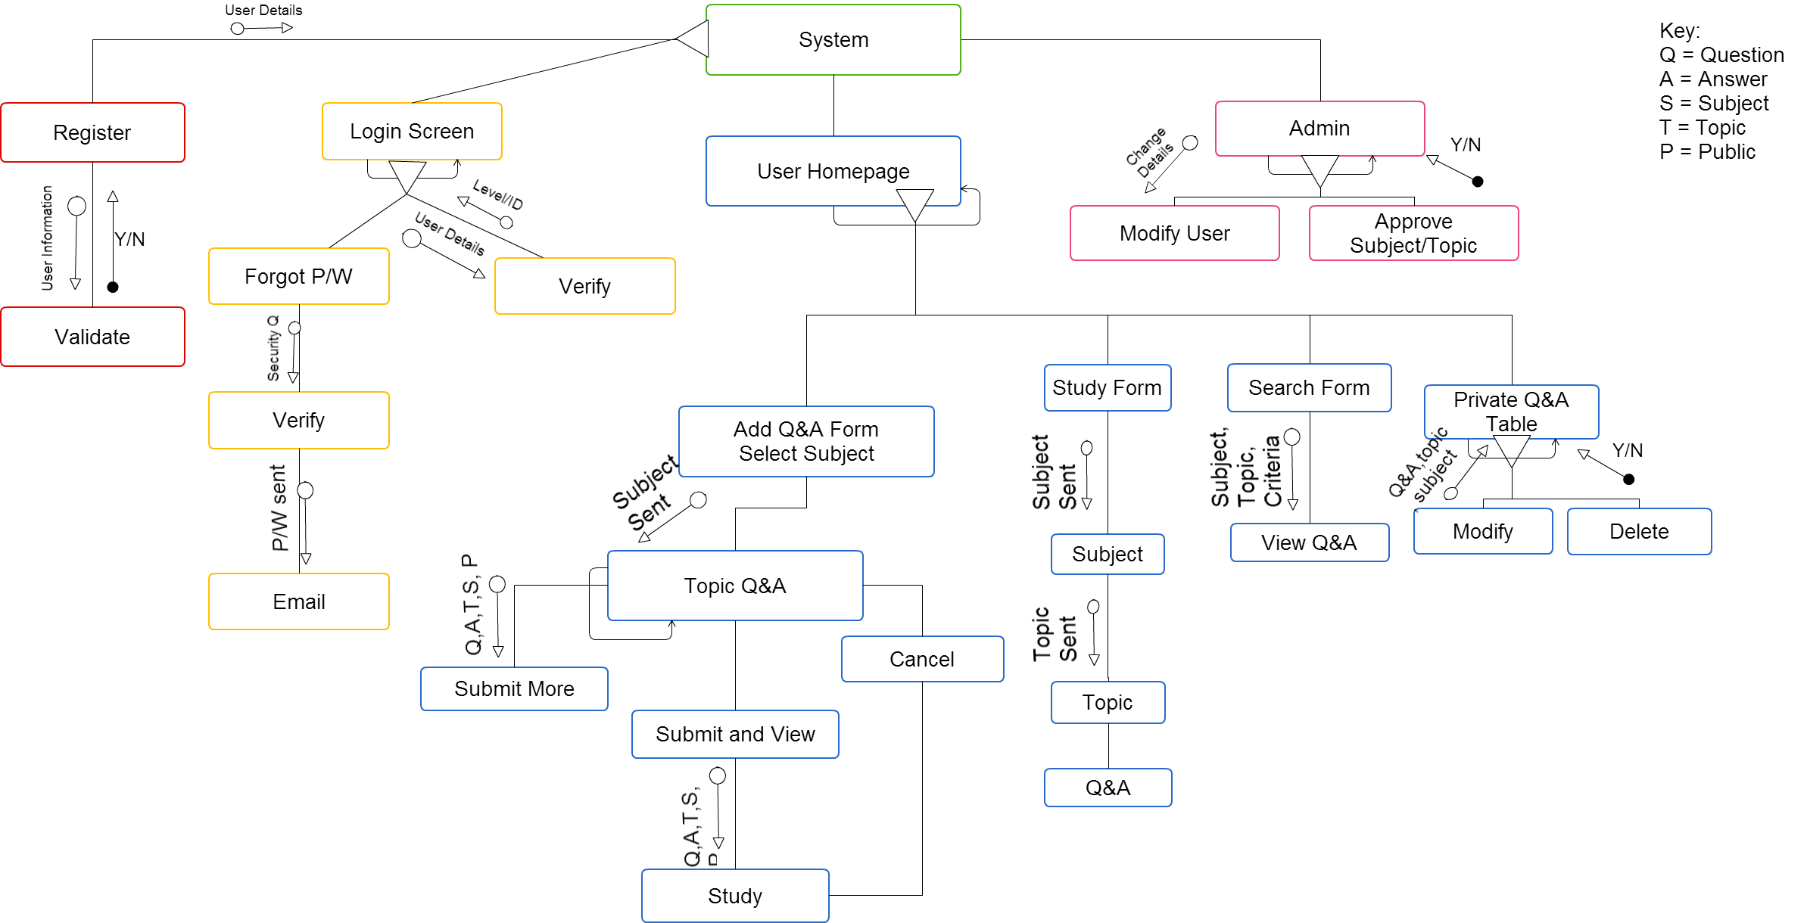

detailed explanation of structure diagrama and functions

The login screen contains two paths that the user can take... These processes may be repeated
1) Forgot P/W
The information passed through forgot P/w is a security question and username into the database. The database then checks if the security is right or not. If verified, correct password is passed to the user via email in their database.
2) Verify
User types in their username and password, verify checks if the data entered matches the data in the database. User level gets passed and determines permissions to use certain aspects of the system. A member (level 1) can use all functionality under User Homepage whilst administrator (level 2) can perform all user tasks with the addition of modifying user details and approving subjects/topics on their Administrator Homepage.
The register function involves entering user information (username, password, email, date of birth, security question). This information is either both validated and stored into the database or the form is incomplete of no valid there is a return of message asking the user to re-enter the information correctly. User Homepage has three main options for the user
- Add Q&A
The user firstly chooses their predefined subject of choice (there will be a hyperlink to a suggestion form for subjects and topics that are desired by the student body) and then they are redirected to the Add Q & A form (see screen designs for more detail). They then choose their topic associated with that subject (again there is a hyperlink to a suggestion form for subjects and topics that are desired by the students), type in Q&A associated with that subject, and the option of making the Q&A public. The students then have 3 options that they can choose from….
- Submit More
By clicking this function the information entered into the Q&A form gets saved into the database, then they are redirected back into the topic Q&A form
- Submit and View
By clicking this function, the information entered into the Q&A form gets saved into the database, they are then are redirected into the Study Page
- Cancel
No information stored into DB, direct to Study Page
- Study Q&A
This function begins with private subject selection of Q&A and then topics associated with that subject. Users then view Questions and have the option of clicking next for the next question or flip to reveal answer. When revision is completed, redirect to Study Page
- Search
This function allows users to search public flip cards and private flip cards. Users search criteria, with the option of narrowing search results (by subject and topic), this can be seen later in the screen designs for the search function.

- Private Question and answer table is a display function that displays all questions and answers a user has created in the system. There are two functions that are in this module
- Modify
Edit questions and answers, possibly moving questions and answers to a different subject/topic, making questions public etc.
- Delete
Remove any unwanted questions and answers from the database.
Admin can perform all system functionality of a user with the addition of two more functions
- Modify User
This function displays a table of all the users in the system. Administrator rights can change details (password, email, webadmin).
- Approve Subject/Topic
This function calls on data collected from the subject/topic suggestion form. Administrators can either approve or cancel the suggestion. Administrators will have to email the students manually however in the next version there will be an in system message system.

Module 1: login

Description
Login module is the beginning stages and one that needs to be implemented for members to use the system.

This login module has the following features:
- 2 User levels (administrator, member)
- Error messages for not entered/invalid data entered
- After login, direct to welcome page

IPO Chart

Input | Processes | Output
Username and Password  Database | Match username and password to the database | Logged in successful, redirection to respective user level pages  Logged in unsuccessful, try again
Username and Password  Database | Check if form filled is blank | Error – Blank fields

Data Flow Diagram

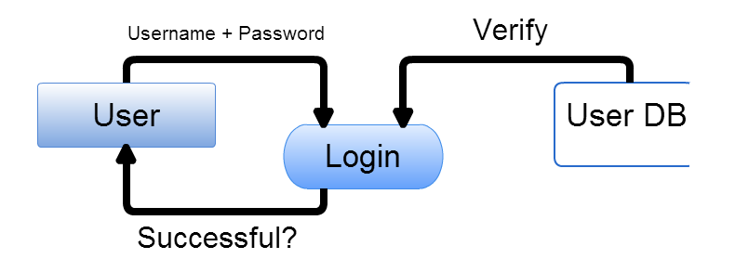

Data Dictionary

Field | Data Type | Length | Description | Example
userID | integer | 8 | Identifier of member | 1
Username | Varchar | 30 | User identification | John
Password | Varchar | 30 | Password identification | abc123
Email | Varchar | 60 | Contact information | john@gmail.com
Webadmin | boolean | 1 | If user is administrator | 1 or 0

Related screens
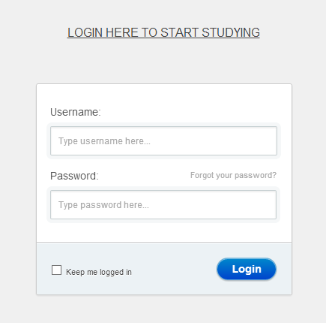
Header: Instructions to start using system
Placeholder: Instructions for user on how login function works
Forgot P/W: For users who have forgotten their password
Keep me logged in checkbox: Uses session to store information about the user to maintain login information as they travel from one page to another until logout.
Login button: direct user to log in the system after credentials are entered

Login button: Once entered, checked with database and will either be successful or not.

ALGORITHM
BEGIN LOGIN (level, end)
set username
set password
set end = false
level=0
IF username OR password = null THEN
return no username or password
ELSE
WHILE end = false and not end of DB
Get usernameDB
Get passwordDB

IF usernameDB = username THEN end = true
IF passwordDB = password THEN
ENDIF
set level = levelDB
set name = nameDB
ENDWHILE
IF level = 0 THEN
message “Incorrect Login/Password”
ELSE
Message “Welcome (name)”
ENDIF
END LOGIN

Module 2: adding question and answer to database

Description:
This function involves adding questions and answers to the database. This is after the user has selected their subject and topic of choice.

IPO Chart

Input | Processes | Output
Enter subject selection page | Generate subject menu in form using identifiers | View Subjects. Clicking next will direct to topic selection page
Click on hyperlink | Send user to subject/topic suggestion form | Form sent to Teacher/Administrator for approval.
Enter topic selection page | Generate topic menu in form using identifiers under subject | There is no output yet as the user has an option to Cancel, Submit more or Submit Question and Answer (see these inputs below)
Insert Question  Insert Answer | Question and Answer is added into the form | There is no output yet as the user has an option to Cancel, Submit more or Submit Question and Answer
Select Public | Radio button highlighted, changes public value to 1 in database | Question and Answer becomes public
Cancel | Data entered is saved to variable in case if pressed by accident | User is directed to private question and answers page
Submit more | Save to DB | Re-display add page
Submit Question and Answer (save all) | Save to DB | Re-direct user to private questions and answers

Data Flow Diagram

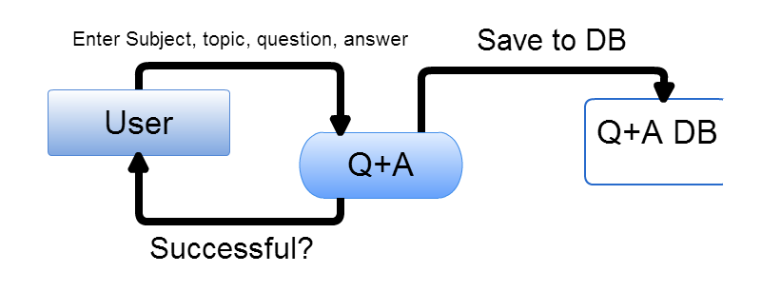

Data Dictionary
Study Database
Field | Data Type | Size | Description | Example
study_id | Integer | 10 | Study set identifier | 1
subject_id | Integer | 10 | Subject identifier | 1
topic_id | Integer | 10 | Topic identifier | 5
user_id | Integer | 50 | User Identifier | 3
Question | Varchar | 100 | Study Question | What does SQL stand for?
Answer | Varchar | 100 | Study Answer | Structured Query Language

Subject Database
Field | Data Type | Size | Description | Example
subject_id | Integer | 10 | Study set identifier | 1
subjectname | Varchar | 100 | Name of subject | Business Studies

Topic Database
Field | Data Type | Size | Description | Example
topic_id | Integer | 10 | Study set identifier | 1
topicname | varchar | 100 | Name of Topic | Finance
subject_id | Integer | 10 | Study set identifier | 1

Related screens (updated from stage 1)
1st Diagram (Left)
Drop Down: List of subjects are displayed for students choice
2nd Diagram (Right)
Header: Tells user what subject they have chosen to write questions and answers on
Drop down: Users choose pre-defined topics associated with subject
Placeholder: Direct user as to where to type in question and answer
Note: Hyperlinks to topic/subject suggestion form for teacher to create a new topic/subject.

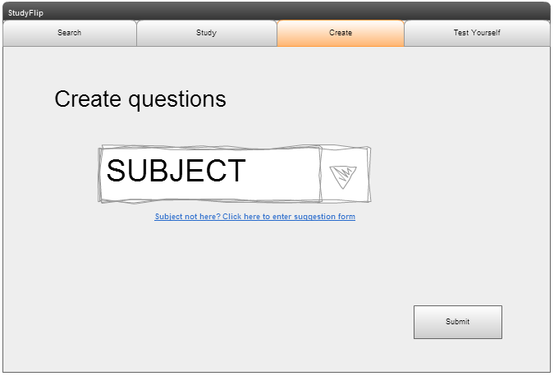
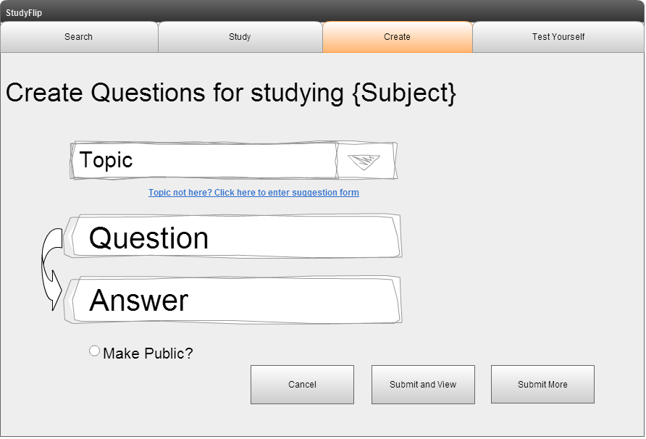

Algorithm
This algorithm is split into two parts. Subject Select and Add Question & Answer
BEGIN subject select
Get subjectname
subjectname = 1
WHILE not end of database
Add subjectname to subject list
subjectname = subjectname + 1
ENDWHILE
Select subjectname
Add QA (subjectname)
END subject select

BEGIN add QA (subject, topic, question, answer)
Get topic
topic = 1
WHILE not end of database
Add topic to topic list
topic = topic + 1
ENDWHILE
Select topic
Get question
Get answer
Get public
IF topic and Question or Answer = null, THEN
Display “form not completed”
Add QA (subject, topic, question, answer)
ELSE
CASE
Insert into study (Question_DB, Answer_DB)
Display entered successfully
ENDIF
END add QA (subject, topic, Q, A)

Module 3: Linear Search

Description
Once questions and answers are entered into the database and are displayed as lists in the question and answers page, a linear search would be helpful to sort subjects/topics of interest.

IPO Chart

Input | Processes | Output
Keywords (by Topic, by Subject) | Search Database for keywords (Topic) | Display Questions and Answers by Topic
If searched by subject | Paginate pages, page 1 containing 10 topics under that subject | Display first page

Data Flow Diagram
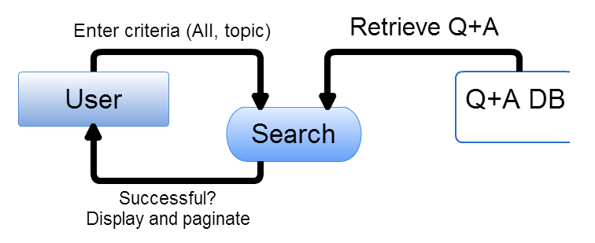

data Dictionary
Field | Data Type | Size | Description | Example
study_id | integer | 40 | Study set identifier | 1
subject_id | integer | 20 | Subject identifier | 1
topic_id | integer | 20 | Topic identifier | 5
question | varchar | 100 | Study Question | What does SQL stand for?
answer | varchar | 100 | Study Answer | Structured Query Language
public | boolean | 1 | Is the question and answer going to be public or private (default)? | 1
user_id | integer | 50 | User Identifier | 3
count | integer |  | Used to get data from array/row in database

Related screens
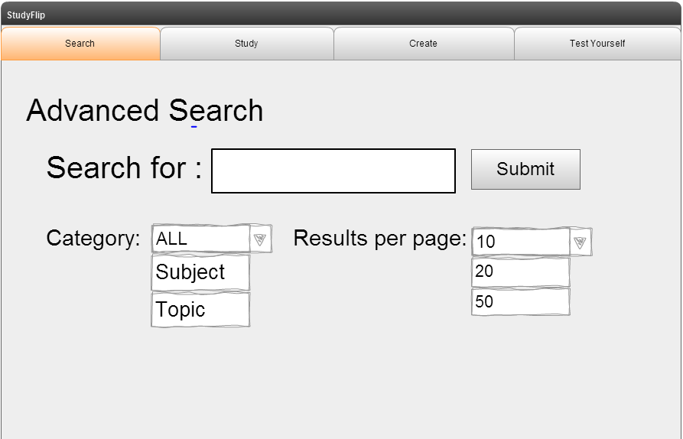
Category: Set default as all, but user also has the option of narrowing down criteria to Subject and Topic
Results per page: Set default as 10 questions and answers per page, but user also has the option of displaying 20 or 50.
Submit button: Searches input in “search for” taking into account category and results per page, then displays data

Algorithm
Begin Search
Index=0
Read search item
Flag=false
WHILE not at end of DB
Count = 0
WHILE not at end of DB and count<10
ArrayName AND Flag=False
Read element in data structure
IF ArrayName (index) = search topic THEN
Display topic
Flag=True
Count = Count+1
ENDIF
END WHILE
Select next page
END WHILE
IF Flag=False THEN
Display “No match found”
ELSE
Display search item found at location
END IF
End Search

